Class Assignment 2.1: Implementing Web Client(Assginment)
In this class, you will develop a simple web client application. you will learn the basics of socket programming for TCP connections: how to [M1] create a socket, connect it to a specific address and port, as well as [M2] [M3] send and receive HTTP packets.
The goal of this assignment is to enhance your understanding of HTTP, the protocol that underpins the World Wide Web, and to gain practical experience with socket programming in Java. The web client you create will be capable of [M2] sending HTTP GET requests to web servers and [M3] processing the responses. By completing this assignment, you will learn how web clients request resources, handle different types of HTTP responses, and display the requested content appropriately.
In this project, you will create a web client program that interacts with a web server. The primary objective of this assignment is to understand how web clients work, how they send requests, and how they handle responses from web servers. You will implement a basic web client that can send HTTP GET requests to a web server and display the response.
- Mission 0: Before Start the Following Missions
  - Draw Block diagram of UDP Web Server & Web Client
  - Draw Flow chart for UDP Web Server & Web Client
- Mission 1: Establishing a Connection to server:
  - Set TCP socket to HTTP Web Server
  - create PrintWirter instance with socket’s OutputStream
  - Get input stream from server, and insert it to BufferedReader instance
- Mission 2: Sending an HTTP GET Request:
  - Send HTTP GET request
- Mission 3: Handling the Response:
  - Read and display the response
Code
Below you will find the skeleton code for the Web client. You are to complete the skeleton code. The places where you need to fill in code are marked with #Fill in start and #Fill in end. Each place may require one or more lines of code.

Running the Client
- Test your web client with various URLs to ensure it handles different types of responses correctly.
- Make sure to test with both existing and non-existing resources to see how your client handles 404 errors and other status codes.
HTTP Client should request several Methods: POST, DELETE, …
Private web client should handle its header(Content-Type, User-Agent, …)
- Handling the Response:
  - Read the response status line and headers.
  - Display the status line and headers.
  - Read and display the content of the response.
- Testing the Web Client
  - Test your web client with various URLs to ensure it handles different types of responses correctly.
  - Make sure to test with both existing and non-existing resources to see how your client handles 404 errors and other status codes.

Program Structure for Web Client

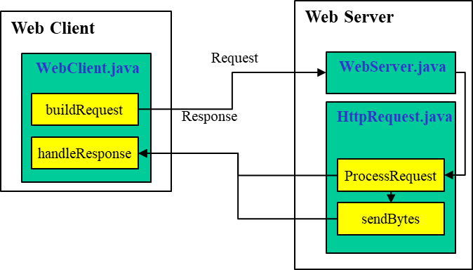
What to Hand in
- Source code files.
- A readme file with instructions on how to compile and run your program.
- The report detailing your implementation.
Skeleton Java Code for the Web Client
This basic example demonstrates how to set up a connection, send a GET request, and read the response from a web server.
WebClient.java
import java.io.*;
import java.net.*;

/**
* WebClient class implements a simple web client.

* Its primary responsibilities include:
* 1. Initializing the tcp connection to web server
* 2. send HTTP request and receive HTTP response
*/
public class WebClient {
public static void main(String[] args) {
// Set the host, port and resource to send HTTP Request
String host = "example.com";
int port = 80;
String resource = "/index.html";
// Mission 1: Establish a socket connection to Server
try (
//Fill #1, Set TCP socket to HTTP Web Server
Socket socket = /*Fill in the Blank*/
//Fill #2, create PrintWirter instance with socket’s OutputStream
PrintWriter out = /*Fill in the Blank*/
//Fill #3, Get input stream from server, and insert it to BufferedReader instance
BufferedReader in /*Fill in the Blank*/ {

/**
* Improve your HTTP Client to provide other request Methods(POST, DELETE, …)
* and also improve to handle headers(Content-Type, User-Agent, …)
*/
// Mission 2: Send HTTP GET Request and Read and display the response
// Fill#4, Send HTTP GET request
out.println("/*Fill in the Blank*/");
out.println("/*Fill in the Blank*/");
out.println("/*Fill in the Blank*/");
out.println();

// Mission 3: Read and display the response
//Fill#5, Read and display the response
String responseLine;
while (/*Fill in the Blank*/) {
/*Fill in the Blank*/
}
} catch (IOException e) {
e.printStackTrace();
}
}
}
OK. You've got the assignment done. The last part of the assignment should be a fun, social thing to do [interoperability test]. Team up with someone from the class and get your client to interact with their server or vice versa. If you’ve got a server up and running, you can advertise your server’s services to anyone in the class (you’re not allowed to charge for service!), and if you’ve got a client, all you need to do is interact with such an advertised server.

Optional Exercises
There can be several improvements for your web clients, following would be your extra goal:
- Handle cookies and sessions. Handling cookies and sessions is crucial for understanding user authentication and state management in modern web applications.
- Improve to handle HTTPs. Improving HTTPS support is essential as it has become the standard for secure communication on the web, teaching students about data encryption and security protocols.
- Application of GUI. Implementing a GUI enhances user experience and and introduces event-driven programming concepts,
- Parallel request through multi-threading. while parallel request handling through multi-threading mirrors the performance optimization techniques used in actual web browsers.
These additional missions for the Web Client project provide valuable learning opportunities that reflect real-world web development challenges. These missions not only deepen the students' grasp of web client functionality but also equip them with practical skills highly relevant in professional software development, bridging the gap between academic learning and industry practices.

Conclusion
By completing this assignment, you will gain a deeper understanding of the HTTP protocol and the interaction between web clients and servers. This knowledge is fundamental for web development and for understanding how web technologies work.

This document outlines the requirements and steps to implement a web client, building on the foundational concepts provided in the web server assignment.
Project Example #2,1: Building a webclient
Name: 왕월수
Student ID: 2019048240
Organization: Department of computer science and engineering, Hanyang Univ. (Seoul, Republic of Korea)

Introduction
In this project, we implemented a simple web client capable of sending HTTP GET requests to a web server and handling the server's response.
Contents of the attachment
WebClient.java – Source code for the web client implementation.
Screenshot of the output after running WebClient
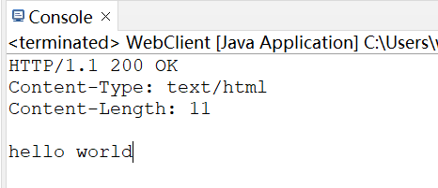
The Wireshark capture shows how the program interacts with the server. The report explains the structure and workflow of the program.
Instructions: How to run the program
Run the server first, then run the client
Wireshark
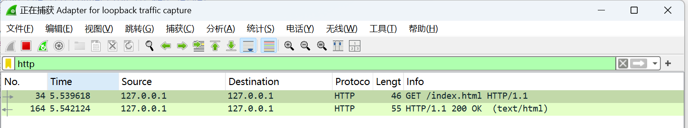
How the program works
Establishing a Connection:The web client establishes a TCP connection to the web server using a Socket. This connection allows the client to send requests and receive responses over the network.
Sending the Request:Once connected, the client constructs an HTTP GET request. The request is sent to the server via the socket's OutputStream using a PrintWriter.
Receiving the Response:The client reads the response from the server using a BufferedReader that wraps around the socket's InputStream. The program then displays the status line (e.g., HTTP/1.1 200 OK), response headers (such as Content-Type and Content-Length), and the body of the response (e.g., the content of the requested file).
Error Handling:The client is designed to handle various HTTP status codes, such as 404 Not Found when the requested resource does not exist, or 200 OK when the request is successful.

